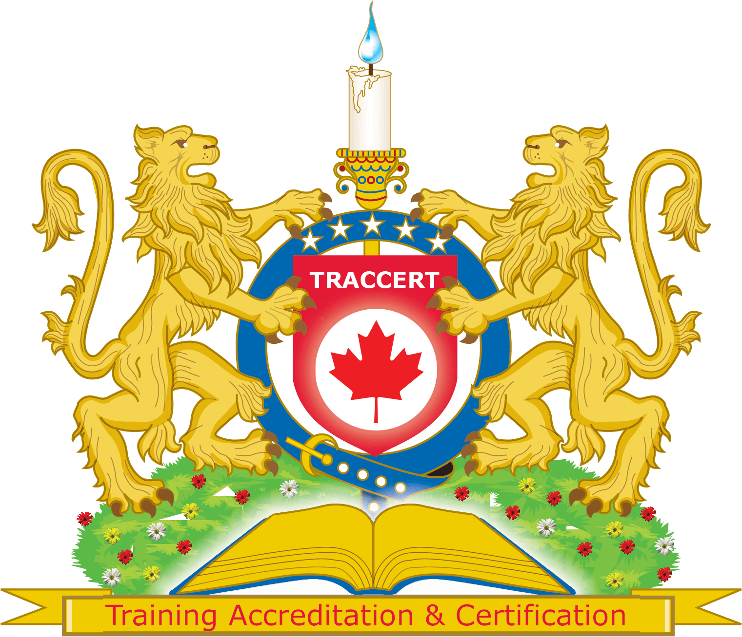
© TRACCERT Training Accreditation & Certification Organization, Canada.
TRACCERT Trainer Application
This document contains information about the
TRACCERT Training Accreditation and Certification Organization Application for Accreditation

T R A C C E R T
Training Accreditation & Certification Organization

www.TRACCERT.org

Summary

There are organizations and bodies that accredit institutes, universities, colleges, schools, and vocational training entities. Then there are accreditation schemes for individuals whereby professional trainers can get accredited for a single discipline.

In case of the certification aspect, there are professional courses – apart from formal education in a university, college or school – that require certification. These courses lead to specific exam-based testing and based on the results; the individual learner is provided with the “pass” certificate.

No single entity accredits a vast majority of trainers and training providers for their training materials, processes, and trainers, and, at the same time, provides opportunities for the learners to have a proof of having attended the approved course from a well-recognized organization. The TRACCERT Training Accreditation and Certification Organization (“TRACCERT” for short) has been conceived and established to cater to the needs of this very segment of training providers and learners.

TRACCERT is an organization formed by internationally qualified trainers with the necessary knowledge, background and expertise in the training industry as well as in process improvement, curricula writing, and standard formation experience.

Before you submit your initial application for further assessment to the accreditation team, here is the framework of our future operations:
- As an accreditation organization, we will assess you and your team through a set of standards and let you know what our accreditation team thinks of your current status, and if you need to provide any further documentation or not.
- The accreditation service itself is free of charge, but we charge US Dollars 1,000 for audits. If you get the accredited status, you will pay a shipping charge of US Dollars 100 to get the hard copies of your accreditation package. So your total investment, if you get accredited, is US Dollars 1,100.
- Once you acquire the accredited status, all your students MUST get a certificate from our organization for all your courses which are accredited by us.
- The certificates cost up to $60 each. If you are an accredited organization, it might cost you less depending on the number of documents ordered at the same time.
- Please note that we do not sell our certificates to candidates or students. Our certificates are issued to only students who attend courses with our accredited partners. This puts you in a unique position to offer your training services.
This information has been put up front as many organizations go onto the accreditation path only to realize that the certificates are a mandatory part of the deal. Your candidates/students can best benefit from the training received if they get the certificates, which are verifiable on our portal and free veritrain.ca service too.

Application for Accreditation
INFORMATION ABOUT TRAINING PROVIDER

Your Name
Company Name (if any)
Your postal address
Your location (if different from above)
Telephone number (with international code)
Email Address
Web address (if any)
For how many years have you been providing training now?
Do you have approval or accreditation with any other organization?
If yes, please name it.
How many trainers do you have? Please include CV
Where do you conduct training?
(your location, temporary location – e.g., hotel)
Do you have the adequate IT system/equipment for the courses?
Please include a list.
What courses do you want accreditation for?
Don’t send the complete curriculum at this stage, just name the courses.
Are these courses accredited or approved by any other organization?
If yes, then please name the organization.
What is the learner’s previous education level for attending this course?
How many students complete training at your center / with you each month?

Please submit as many as you can from the documents listed below:

Audit Requirements

- List of staff and CVs for each of them;
- List of courses/programs to be accredited – you need to mention name of staff who trains each program from CVs list;
- Record of resources (other than staff) to support the training – such as hardware/software;
- Initial assessment plans, learning objectives, course materials, and final assessment formats;
- Support for candidates with particular needs/disabilities – such as easy access to the center;
- Appeal forms, guidance and outcome information – in case students need to complain;
- Register of queries and feedback;
- Information management systems such as a candidate register system;
- Assessment requirements provided to learners;
- Internal standard operating procedures and records;
- Candidates’ portfolios, internal assessment plans, assessment sampling policy, and strategy;
- Assessment staff’s detailed CVs;
- Evaluation surveys and customer feedback; and
- Learners’ data protection systems.
- Quality processes including progress reports and staff updates;
- Well-documented access and fair assessment policy review mechanisms;
- Organizational charts, agreements, and internal quality assurance documents;
- Staff handbooks, minutes of team meetings, and records of communication;
- Trainers’ development plan vs budget allocations;
- Printed materials showing the available services, and information sheets about courses;
- Learners’ records and assessment plans, and objectives and systems to track progress;
- Self-assessment and audits, gaps identified and corrective actions taken;
- Audit report vs improvement plan; and
- Achievement records, and reports based on different criteria (such as gender and disability).

